SIMATS ENGINEERING (SAVEETHA SCHOOL OF ENGINEERING)
Department of Computer Science and Engineering

ASSESSMENT TOOL 2 – CASE STUDY

Course Code: | CSA06 | Course Title: | Design and Analysis of Algorithms
CO Assessed: | CO3: Articulation (BL4, BL5) | Assessment: | Assessment Tool 2 – Case Study
Weightage: | 20% of CIA | Total Marks: | 100
CO3 Statement: | Design Divide and Conquer algorithms for Merge Sort, Quick Sort, Binary Search and Matrix Multiplication
Student Name: | DINESH KARTHICK R | Reg. No.: | 192524121
Section / Batch: | 02 | Date: | 06/08/2026
Instructions to Students
- Answer the following question. Total Marks: 100.
- Carefully analyze the given case study questions.
- Explain in detail with sample code if needed.
- Clearly identify all key issues, provide an in-depth analysis, and propose innovative, feasible solutions with strong justification.

Question Type | Focus Area | Questions
Case Study | Focus on Design Divide and Conquer algorithms: Merge Sort, Quick Sort, Binary Search and Matrix Multiplication | Q1
SECTION A – CASE STUDY

Airline Reservation Sorting System (Merge Sort)

Q1. An airline reservation system sorts flight bookings based on departure time and priority. Analyze how Merge Sort ensures stable and efficient sorting. Identify issues such as large data volume and real-time updates. Apply divide and conquer techniques to explain the process. Analyze time complexity and design a solution, justifying its effectiveness.

Code of Conduct
I DINESH KARTHICK R (192524121) (Name / Reg No) certify that this submission is my original work and that I have adhered to the guidelines specified for this assessment. I understand that any violation of academic integrity rules will result in disciplinary action.
Signature of the Student: DINESH KARTHICK R

RUBRICS FOR CALCULATION

Case Study
Criteria | Weightage | Level 4 – Exemplary | Level 3 – Proficient | Level 2 – Developing | Level 1 – Beginning
Understanding of Case | 25% | Thorough understanding; clearly identifies all key issues | Good understanding with most issues identified | Basic understanding; some issues missed | Poor understanding; problem not identified correctly
Application of Concepts | 25% | Effectively applies relevant concepts to analyze the case deeply | Applies appropriate concepts with minor gaps | Limited application of concepts | Fails to apply relevant concepts
Analysis | 20% | In-depth analysis with strong  reasoning and insights | Good analysis with logical reasoning | Basic analysis with limited depth | Weak or no analysis; lacks reasoning
Solution Design | 20% | Innovative, feasible solutions with strong justification | Logical solutions with adequate justification | Basic solutions with weak justification | Incorrect or no solution provided
Clarity | 10% | Clear, well-structured, and easy to  understand | Organized and understandable presentation | Limited clarity and structure | Poor clarity; difficult to understand

Marks Evaluation:
Criteria | Wt. | Level 4 – Exemplary | Level 3 – Proficient | Level 2 – Developing | Level 1 – Beginning
Understanding of Case | 25%
Application of Concepts | 25%
Analysis | 20%
Solution Design | 20%
Clarity | 10%
Total Marks (100):

Faculty In-charge | Course Coordinator | Head of Department
Name: | Name: | Name:
Signature: | Signature: | Signature:
Date: | Date: | Date:

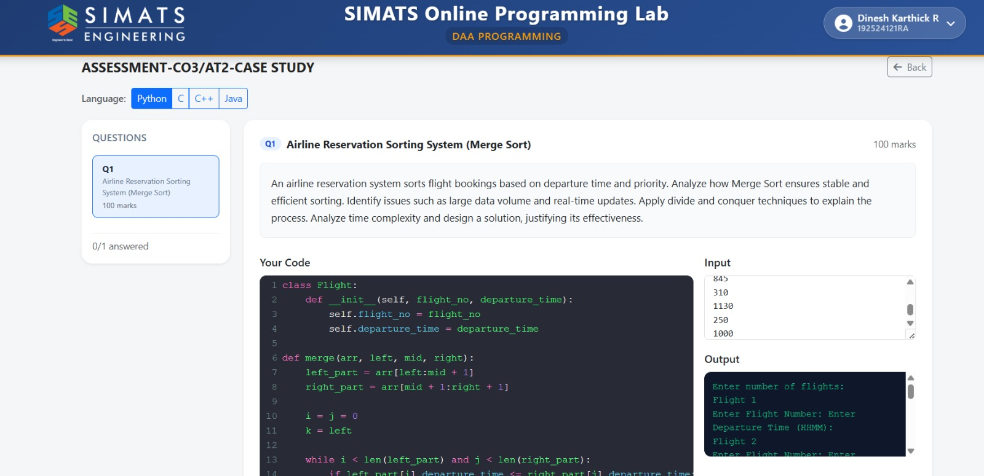

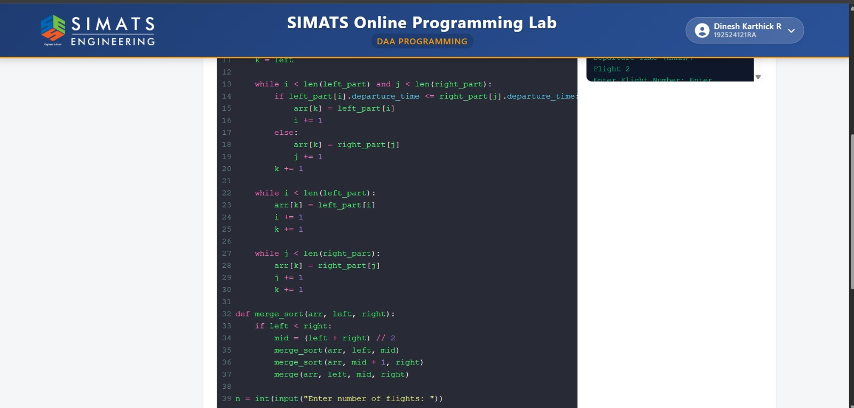

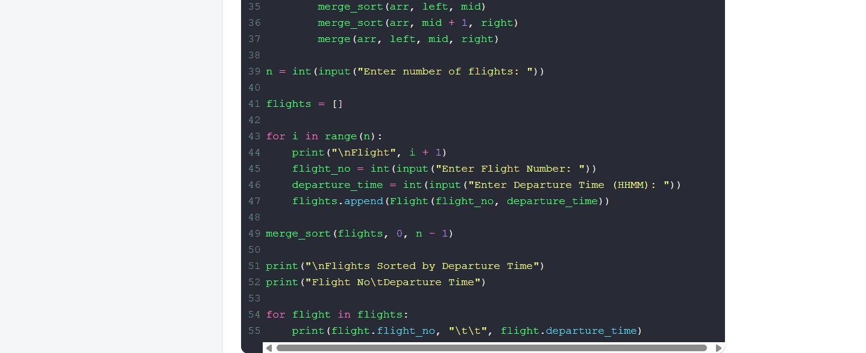

1. Merge Sort
Merge Sort is a sorting algorithm that arranges flight bookings in ascending order of departure time. It divides the list into smaller parts, sorts them, and merges them into a sorted list.

2. Stable Sorting
Merge Sort is a stable sorting algorithm. If two flights have the same departure time, their original order is maintained after sorting.

3. Large Data Volume
Airline reservation systems contain thousands of flight bookings. Merge Sort handles large datasets efficiently because it always works in O(n log n) time.

4. Real-Time Updates
When new flight bookings are added, the list must be sorted again. Merge Sort is suitable for batch updates but repeated sorting may be required for frequent real-time changes.

5. Divide and Conquer Technique
Merge Sort follows the Divide and Conquer approach:
- Divide the flight list into two halves.
- Sort each half recursively.
- Merge the sorted halves into one sorted list.

6. Time Complexity Analysis
- Best Case: O(n log n)
- Average Case: O(n log n)
- Worst Case: O(n log n)
- Space Complexity: O(n)

7. Solution Design
The solution stores flight numbers and departure times, applies Merge Sort to arrange the flights by departure time, and displays the sorted flight list.

8. Justification of Effectiveness
Merge Sort is an effective solution because it provides fast and stable sorting, performs efficiently for large datasets, and guarantees O(n log n) performance in all cases. It is suitable for airline reservation systems where accurate scheduling is important.

